Assignment #3

1. **Question 1**:

Develop algorithms for generating each of the codes shown in slide 29 of the Session 3 slide deck on Data Encoding and Transmission from NRZ-L.

Answer (Sample solution):

* 1. NRZL

For i = 1 to input_length

If input(i) is zero; output(i) = “+” Else output(i) = “-“

* 1. NRZI

For i = 1 to input_length If input(i) is one {

If output(i-1) is “+”; output(i) = “-“ Else output = “+”

} else output(i) = output(i-1)

* 1. Bipolar AMI

For i = 1 to input_length If input(i) is one {

If previous is “-“; output(i) = “+”; previous = “+” Else output(i) = “-“; previous = “-“

} else output(i) = “neutral”

* 1. Pseudo Ternary

For i = 1 to input_length If input(i) is zero {

If previous = “-“; output(i) = “+”; previous = “+” Else output(i) = “-”; previous = “-”

} else output(i) = “neutral”

* 1. Manchester

For i = 1 to input_length

If input(i) is zero; output(2*i-1) = “+”; output(2*i) = “-“ Else output(2*i-1) = “-“; output(2*i) = “+”

* 1. Diff Manchester

If output(i) is one; output(1) = “+”; output(2) = “-” Else output(1) = “-“; output(2) = “+“

For i = 2 to input_length

If input(i) is one; output(2*i-1) = output(2*i-2); output(2*i) = output(2*i-3) Else output(2*i-1) = output(2*i-3); output(2*i) = output(2*i-2)

1. **Question 2:**

Enhanced NRZ (E-NRZ) is used for high-density recording on magnetic tape. It separates the NRZ-L data stream into 7-bit words, inverts bits 2, 3, 6, and 7, and adds a parity bit to each word. In this case, the parity bit is chosen to make the total number of 1s in the 8-bit word an odd count. Explain the advantages and disadvantages of E-NRZ over NRZ-L.

Answer: There are many possible answers for this.

1. **Question 3:**

For the bit stream 01010101, sketch the corresponding waveforms for NRZ-L, NRZI, Bipolar-AMI, Pseudoternary, Manchester, and Differential Manchester. Assume that the signal level for the preceding bit for NRZI was high; the most recent preceding 1 bit (AMI) has a negative voltage; and the most recent preceding 0 bit (pseudo ternary) has a negative voltage Solution:

Answer:

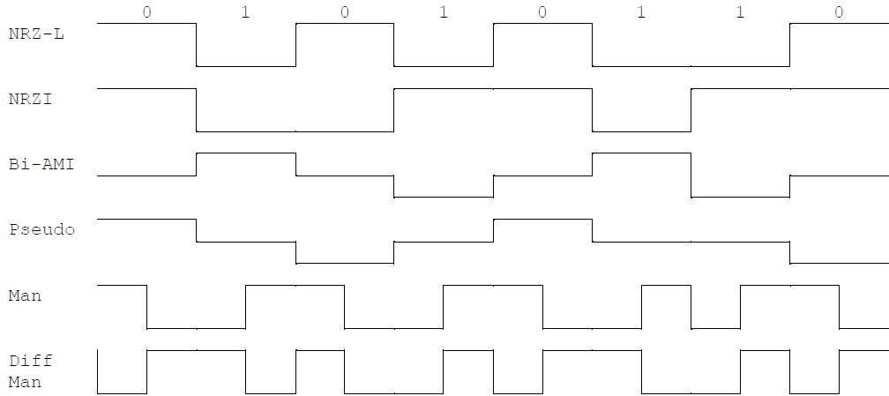

1. **Question 4:**

Consider a stream of binary data that consists of a long sequence of 1s followed by a zero followed by a long string of 1s and the same assumptions as in Problem 3 above. Draw the waveform for this sequence using:

* 1. **NRZ-L**
  2. **Bipolar-AMI**
  3. **Pseudoternary**

Answer:

